
NAME: ……………………………………………………
TEACHER: GON KAU FDE ABU

St Aloysius’ College
Year 9
Yearly Examination
2016

MATHEMATICS (5.3 course)

General Instructions  Reading time – 5 minutes  Working time – 1 hours  • Write using black pen only.  • Board approved calculators may be used  • All necessary working should be shown in every question in the spaces provided.  • Marks will be deducted for careless and poorly arranged work  • Examination papers must NOT be removed from the examination room. | Total marks − 80  Attempt all questions  Section A – Multiple Choice (20 Marks)  • All questions are of equal value  • These are objective response questions.  • Circle the correct answer on the examination booklet.  Section B − Short answer (20 marks)  Section C − Working required (40 marks)

SECTION A MULTIPLE CHOICE:

• The following 20 Multi-Choice questions have only one correct answer.
• Circle the correct answer (A), (B), (C) or (D) in the examination booklet.

1. Round 758.758 to the nearest tenth:

(A) 758.76 (B) 759 (C) 758.7 (D) 758.8

2. Nathan spends of his pay on food and on rent. He banks the remainder.
What fraction of his pay is banked?

(A) 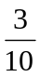 (B) 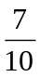 (C) 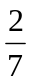 (D) 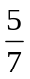

x
y
(5, 6)
P
Q
O
3. What are the coordinates of P and Q?

(A) P(0, 5) and Q(6, 0)

(B) P(0, 6) and Q(5, 0)

(C) P(6, 0) and Q(0, 5)

(D) P(5, 0) and Q(0, 6)

4. For the triangle shown, Pythagoras' Theorem states that:
m
n
k
(A) k² = m² − n²

(B) n² = (m + k)²

(C) m² = n² − k²

(D) n² = m² − k²

5. Luke earns $1,746.50 per fortnight.

What is his yearly income, to the nearest dollar?

(A) $45,409 (B) $91,132 (C) $90,818 (D) $45,566

6. 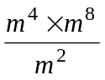 simplifies to:

(A) m¹⁶ (B) m¹⁰ (C) m⁸ (D) m⁶

7. The simple interest on $1,200 for 5 months at 6% per annum is:

(A) $3,000 (B) $72 (C) $360 (D) $30

8. Factorise 3x² + 24x.

(A) 3(x² + 8) (B) 3x(x + 8) (C) 3(x² + 12) (D) 3x(x + 12)

9. The parabola shown could have equation:
y
x
0

(A) y = − x² + 3

(B) y = − x² − 3

(C) y = x² − 3

(D) y = x² + 3

10. Julianne draws one card from the eight which are shown below.

What is the probability that she draws a card which has an A or a 9, but not both?

(A)
A1
B4
A7
U2
K9
W8
Q8
A9

(B) 

(C)

(D) 

11. In which diagram is the angle of depression of P from W equal to 40º ?

(A) (B) (C) (D)
40º
W
P
40º
W
P
40º
W
P
40º
W
P

12. The gradient of the line is:
x
2
(−6, 5)
y
NOT TO
SCALE

(A) −2

(B) −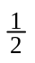

(C) 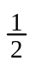

(D) 2

13. Susilo has a gross annual income of $69 000.00 and eligible tax deductions which total $1 255.00.
Use the table below to calculate the amount of income tax he must pay.

Taxable Income | Tax on Taxable Income
$0 − $18,200 | NIL
$18,201 − $37,000 | 19 ¢ for each $1 over $18,200
$37,001 − $80,000 | $3,572 plus 32.5 ¢ for each $1 over $37,000
$80,001 − $180,000 | $17,547 plus 37 ¢ for each $1 over $80,000
$180,001 − and over | $54,547 plus 45 ¢ for each $1 over $180,000

(A) $3 572.00

(B) $9 992.13

(C) $13 564.13

(D) $22425.00

14. Which statement is correct?:
v
m
α
(A) m = v cos α

(B) v = m sin α

(C) m = v sin α

(D) v = m cos α

15. The equation of the graph is:
x
5
y
0
−2

(A) 2x − 5y − 5 = 0

(B) 5y − 2x + 5 = 0

(C) 5x − 2y + 10 = 0

(D) 2y + 5x − 10 = 0

16. 5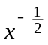 = ?

(A) −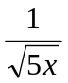 (B) 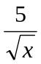 (C) 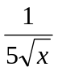 (D) 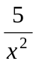

17. The solution to 1 − 2x ≤ 7 can be represented by:

−5
−4
−3
−2
−1
0
1
2
3
4
−5
−4
−3
−2
−1
0
1
2
3
4
−5
−5
−4
−4
−3
−3
−2
−2
−1
−1
0
0
1
1
2
2
3
3
4
4
(A)

(B)

(C)

(D)

18. If 16m² − 24m + P = (4m + Q)², then:

(A) P = 9 and Q = 3

(B) P = −9 and Q = −3

(C) P = −9 and Q = 3

(D) P = 9 and Q = −3

19. Make G the subject of the formula V = 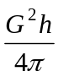 for G > 0.

(A) G = 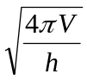

(B) G = 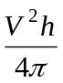

(C) G = 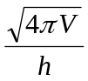

(D) G = 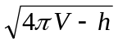

20. The diagram shows a quadrant of a circle, and a right triangle.

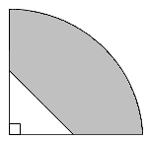
The shaded area is:
2 m
2 m
2 m
2 m

(A) (4π − 4) m²

(B) (16π − 2) m²

(C) (16π − 4) m²

(D) (4π − 2) m²

End of SECTION A − Multiple-Choice Section

SECTION B
NAME: ……………………………………………………
TEACHER: GON KAU FDE ABU

Short Answer Questions: 20 questions. All questions are worth one mark. 20 marks
Give your answer only in the right-hand column.
Working out may be shown in the left-hand column.
Answer

1. Evaluate 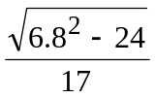 correct to two decimal places.

2. What percentage of $5 is 80 cents?

3. Expand and simplify − 2(3x + 4)

4. Find the value of 4h³ − 3gh if g = 6 and h = −2.

85 cm
h cm
26º
5. Calculate the value of h. (to 1 dec.pl.)

6. Expand and simplify (3x −8)(2x + 5).

7. Expand and simplify (2m − 5)².

8. Express 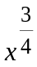 in surd form.

9. Calculate the perimeter, giving answer to the nearest whole number.
16 cm
70º

10. Determine the gradient of the straight line with equation: 8 − 2y = 6x

11. Simplify 2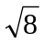 × 3

12. Calculate the compound interest earned when $32 000 is invested for 6 years, at
an interest rate of 8 % p.a., compounded yearly. Give answer to the nearest dollar.

13. The ages of movie-goers at a cinema was recorded by management, and then
displayed in the box-and-whisker plot.
If there were 528 people at a session,
13
14
15
16
17
18
19
20
21
how many were aged 17 or more?

14. Solve for x, the equation: 8x − 15 = 6x +9

15. Determine the True bearing of A from C.
A
30º
N
N
40º
B
C

16. The graph of the given parabola has its monic quadratic equation in the form:
y = (x − h)² + k.

Write the equation of the parabola in the above form.
0
y
x
−2
−3

17. An army platoon, on manoeuvres, leaves its base camp A and walks due north
for 15 km to camp B. They rest, and then walk 8 km due east to camp C.
They then return to base camp A along a direct straight line AC.
Calculate the True Bearing of A from C, to the nearest degree

N
B
15
A
C
8

18. A car is now worth $13 000. What was its original price, if it was bought
9 years ago, and depreciated at an average yearly rate of 12 % p.a.
Give the answer to the nearest thousand dollars.

19. Calculate the length of the interval AB.
Give answer to one decimal place.
y
A(−7, 10)
x
0
NOT TO SCALE
B(3, −2)

20. A spinner has 3 numbers 1, 2, and 3, as shown.
1
2
3

The spinner is spun twice, forming 2-digit numbers.
Complete the tree diagram below
1
2
3
2
3
1

Calculate the probability of spinning an odd 2-digit number.

End of SECTION B

SECTION C
NAME: ……………………………………………………
TEACHER: GON KAU FDE ABU

Free Response Questions: 40 marks

All necessary working is to be shown for Section C.
Marks for each question are given on the right hand side of the page.

1. Convert 257369473 into scientific notation, giving the answer to 3 significant figures.
2

2. Simplify: 3k⁷p⁻⁵ × (2 p³k⁴)³
2

3. Simplify 3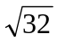 + 4, leaving answer in exact form.

2

4. A water trough, in the shape of a half cylinder, is shown.
Calculate the capacity of the trough, to the nearest litre.
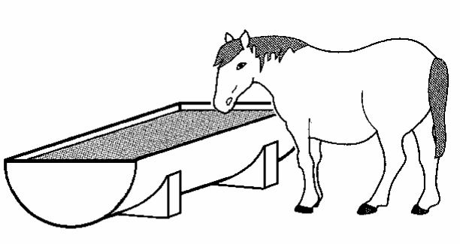
4 m
1.2 m

2

.

5. Factorise fully 12p + 5m − 4mp − 15

2

6. Simplify 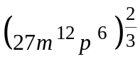, giving answer in simplified index form.
2

7. The stem-and-leaf plot below represents the percentage marks scored by the Year 9 advance students in their Yearly exam.

Year 9 Test Marks
5  6  7  8  9 | 4 7 8 9  0 2 4 5 6 6 7 8  1 3 5 7 8 8 9  2 5 7 8  1 4 5

(i) Determine the median.

2

(ii) Determine the interquartile range.

8. Factorise fully 100x² − 4y².

2

9. The Venn diagram shows the number of students playing Rugby (R) and/or Soccer (S)
R
S
25
48
15
32
What is the probability that a student chosen at random:

(i) Plays Soccer?

2

(ii) Does not play rugby?

10. Solve the equation for m. 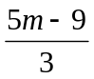 + 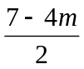 = 4

3

11. Factorise 5x² + 6x − 8.

2

12. Factorise and then simplify fully: 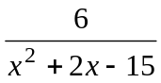 − 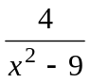

3

13. By solving the quadratic equation y = x² − 4x − 12, sketch the graph of its parabola,
on the number plane below, showing all the relevant features, such as the x and y intercepts, and coordinates of the vertex.
y
x

3

14. Substance A (initially 30g) decays at a rate of 1 grams per min, while substance B (initially 20g), decays at a rate of grams per minute.
Let y_{A} and y_{B} grams be the amount of substances A and B respectively at time t minutes after the substances begin to decay.

(i) Write down the equations for y_{A} and y_{B} in terms of t.

2

(ii) Find the time it takes for substance A to decay to 0 grams.

1

(iii) How long does it take for both substances to have the same weight?

2

15. A gardener decides to subdivide a rectangular garden bed of area 30 m² into three equal sections..
He places edging along the outside of the garden bed and as dividers between each section.
It takes 32 metres of edging.
Each of the three sections of garden have length y metres (which is also the length of each divider), and width x metres.
x m
x m
x m
y m

(i) Show that the area of the entire garden bed is:
A = x(16 − 3x) m².

2

Question 15 continues on the next page
Question 15 continued

(ii) Hence find the two possible sets of dimensions of the garden bed.

4

End of Exam

